USER INTERFACE DESIGN

EXPERIEMENT – 2

NAME:ZARAA JUHI SAAI K

ROLL NO: 240701044

Design a UI where users recall visual elements (e.g., icons or text chunks). Evaluate the effect of chunking on user memory.

Introduction:
Chunking is a cognitive strategy that involves breaking information into smaller, meaningful units. This experiment uses a game-based UI to analyze how chunking improves short-term memory recall by presenting visual elements within a limited time.

FRAME 1: INSTRUCTION PAGE

Chunking Analysis
The instruction page effectively applies chunking by presenting information in a structured and organized manner.

Clear Sequential Steps
Instructions are divided into numbered steps, making them easy to understand and follow.

Logical Grouping
  - Observation Phase – explains what users will see.
  - Memorization Phase – encourages focusing on remembering items.
  - Recall Phase – explains how users should recall items.
  - Performance Metric – accuracy is emphasized over speed.

Visual Hierarchy
A bold title, proper spacing, and a highlighted START button guide the user clearly.

Time Awareness
Users are informed that they have only 5 seconds, preparing them to focus.

Simplicity
Short sentences and minimal text reduce cognitive load.

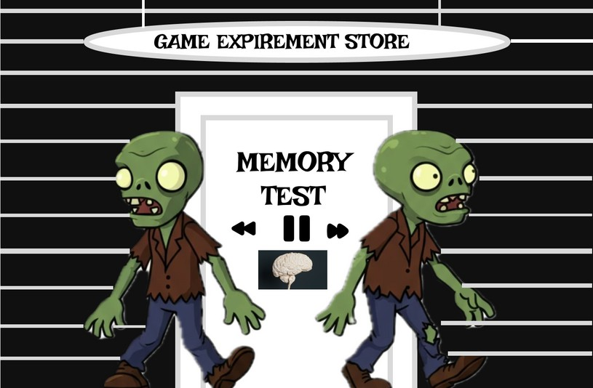

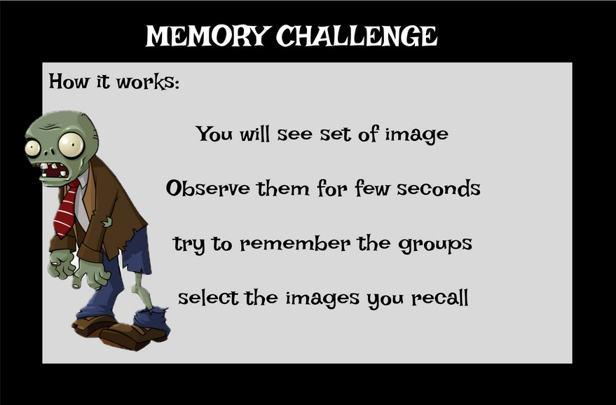

FRAME 2: CHUNKING PHASE

Analysis of Chunking Phase Screen

Purpose:
This is thememory encoding stage where users observe icons and mentally group them.

UI Elements:
- Countdown Timer (10 seconds) to create urgency.
- Progress bar to visualize remaining time.
- Grid of icons arranged to support grouping by category, color, or similarity.

Working:
Usersquickly scan and form mental chunks before time ends.

Cognitive Benefit:
Chunkingreducesmemory load and improves recall efficiency.

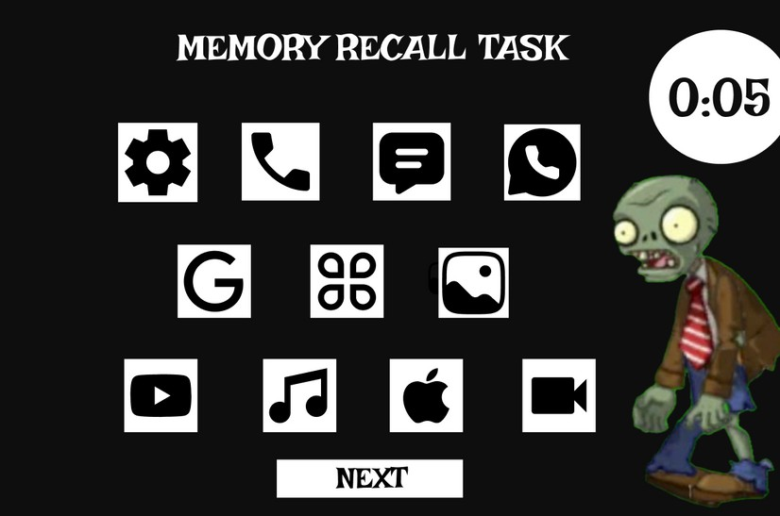

FRAME 3: RECALL PHASE

Analysis of the Recall Phase

- Purpose
  - Tests memory by asking users to recall previously seen icons.
  - Measures the effectiveness of chunking.

UI Elements
  - Title & Instructions: Clearlyexplain the task.

Multiple Choice Icon Grid:
    - Contains both correcticons and distractors.
    - Users mustidentify previously seen items.

Radio Buttons:
  - Easy andclear selection method.

Submit Button:
  - Confirmsuser choices.

Working Principle
- Users recall icons from memory.
- Select remembered icons.
- Distractors test memory accuracy.
- Submit leads to result page.

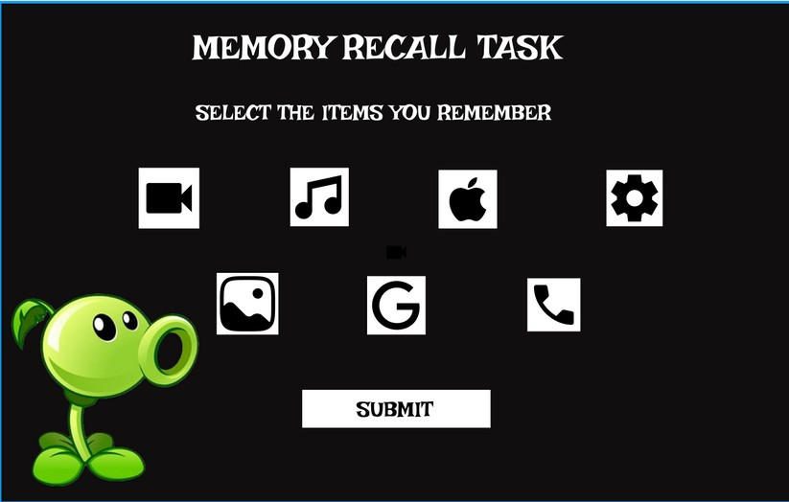

FRAME 4: RESULT PAGE

Analysis of the Result Page

- Purpose
  - Displays recall accuracy.
  - Provides feedback and next actions.

UI Elements
  - Score Display (e.g., 6/9):
o Shows performanceclearly.

Action Buttons:

  - Play again: Move to next level.
  - Home: Endthe activity.

Working Principle
- System evaluates selected icons.
- Calculates score.
- User chooses next action.

Cognitive & UX Benefits
  - Immediate feedback improves learning.
  - User control enhances experience.
  - Gamification reduces stress and increases motivation.

